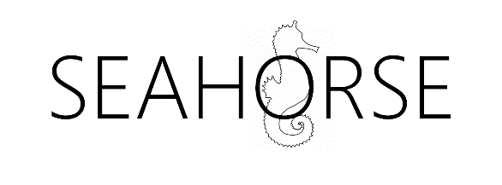

Seahorse:

Project One Report

Date: 11 October 2018

Author: Michael McGrath

Reviewers:

Javier Lopez, University of Warwick

More to be added

Version History

V0.0 First draft, not for review

List of figures

Figure 1 Original Data Lifecycle Model (ODLM) 5

Figure 2 DLM as presented by Lenhardt et al., 2014 7

Figure 3 DLM as presented by Spirion 9

Figure 4 ITTStar DLM 10

List of Tables

Table 1 ODLM mapped to Texas A&M Model 6

Table 2 ODLM Mapped to RAMP Model 6

Table 3 ODLM Mapped to Bloomberg Model 8

Table 4 ODLM Mapped to Spirion Model 9

Table 5 ODLM Mapped to ITTStar Model 10

Table 6 Data Lifecycle Model 12

# Introduction

This paper is the output from the first Seahorse project. The goal of this project is to define a working data. This paper describes the first Seahorse project. The goal of this project is to define a working data lifecycle model (DLM) that is practical in use and is as complete as possible. The DLM is based of the Initial data lifecycle model, described below.

## The growing role of data.

The growth in data is exceptional. While estimated of just how much data exists vary all estimates show the same trend, exponential growth. Khoso (Khoso, 2016)estimates that data in 2016 totalled around 4.4 Zetabytes[1] and that that would grow to ten times that by 2020. Even email is growing by over 4% per year (Radicati & Hoang, 2017). In tandem with the growth in data there is a corresponding growth in storage required to persist that data. Additionally, we see that the majority of that data is in unstructured forms; Khoso (Khoso, 2016) estimates that about 90% of data created is unstructured, this view is supported by practitioners (V Cloud News, 2015) who also asserted that 90% has been created in the last year.

There is also great value to this data, for example a report by focusing on data in the automotive industry suggests that *“The expected growth of the value pool from car data and shared mobility could add up to more than USD 1.5 trillion by 2030”* (Balasubramanian et al., 2016) and that this data used in AI *“… could potentially deliver additional economic output of around $13 trillion by 2030, boosting global GDP by about 1.2 percent a year”* (“Modeling the global economic impact of AI | McKinsey,” n.d.).

In addition, some practitioners have reported other problems most notably that there are no common data formats, little metadata and little interoperability because the systems exist in independent and distinct systems (Sohn, 2017). It is even asserted that these issues place such a financial burden on the health industry as to be a noteworthy contributor to rising costs (Wang, Kung, & Byrd, 2018).

The DLM is important because it will provide the basis for the next project which will describe an objective method and model to identify the total lifecycle cost and value of data.

The goal of this project is to define a robust data lifecycle model (DLM) for future research to be based upon. In addition, the goal of the DLM is to

*“The goal of a data management lifecycle is to ensure that … data are collected with enough rigor to support the intended use, to support basic data management, to enable reuse and repurposing of the data, and to allow for the eventual long-term preservation and management of the data.”* (Lenhardt, Ahalt, Blanton, Christopherson, & Idaszak, 2014)

## Methodology

The method used is simple. A search of documented DLMs was performed and where there were gaps or differences identified these were evaluated and the original DLM was modified or not, accordingly.

# Initial data lifecycle model

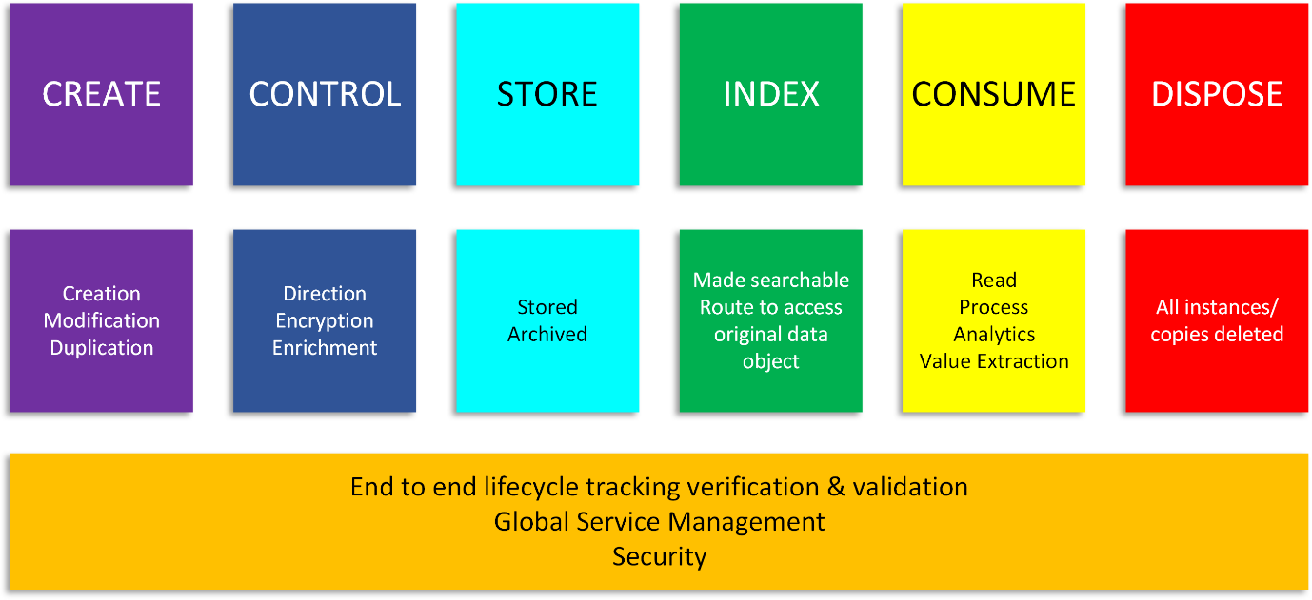

Figure Original Data Lifecycle Model (ODLM)

# Documentation reviewed

This section describes the literature reviewed. The definition of literature is wider than the “usual” so as to include practitioner models which are often found published in books or web pages. The goal of this project to create a complete model for the data lifecycle which is robust enough to be applicable in any circumstance. Some of the models examined here such as the DCC (Higgins, 2008) are designed to cover specific purposes and therefore have too narrow a focus for the purposes of this research. That said these are still examined because there may be elements within them that are useful additions to the original model.

Though based on the transport sector the Texas A&M Transportation Institute (Miller, Miller, Moran, & Dai, 2018) identifies seven major stages in the data lifecycle this model has a number of differences from the original model. The most significant are it separates storage from archiving, this is something that other models do also. However, in the model we keep these together for a number of reasons, the two most significant are that firstly archival storage, even compliant storage such as 17a-4 (FINRA, 2014; “Regulatory Notice 17-18 Guidance on Social Networking Websites and Business Communications,” 2017) storage is still nonetheless storage. The second reason is that as the cost and capability of storage improves in line with “Moore’s Law” (Moore, 2007) we see a growing to consume data “in place” from the archive. Thus, over time we see in our business this trend emerging. This is obviously an ontological position of the author and his colleagues at this juncture.

These stages can be broadly mapped to the original model as follows:

Table ODLM mapped to Texas A&M Model

|  |  |
| --- | --- |
| **Original Model** | **Texas A&M model** |
| Create |  |
| Control | Collection Process |
| Store | Store & Secure[2] |
| Index |  |
| Consume | Use Share and communicate |
| Dispose | Destroy or re-use (concurrent phases). |

Archive

They also explore other related aspects of data lifecycle management:

* Purpose and value
* Privacy
* Data ownership
* Liability
* Public perception
* Security
* Standards and Data Quality

These topics are out of scope for this project, but they will be examined in later research.

A similar DLM is found in a description of the Research Data Management Platform (RDMP) (Nind et al., 2018) which is a longitudinal research dataset. They found similar stages to the ODM, which are Create, Process, Analyse, Presenting, Give access (reuse). These map fairly closely as can be seen in the table, below:

Table ODLM Mapped to RAMP Model

|  |  |
| --- | --- |
| **Original Model** | **RDMP Model** |
| Create | Create |
| Control | Process |
| Store |  |
| Index |  |
| Consume | Presenting Give access |
| Dispose |  |

In a web publication entitled “Data Management Lifecycle and Software Lifecycle Management in the Context of Conducting Science” (Lenhardt et al., 2014) published an DLM with some interesting additional features. The model is shown below:

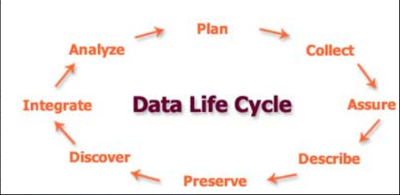

Figure DLM as presented by Lenhardt et al., 2014

This model call for DLM to have additional elements of assure and describe. Assure is part of the ODLM as the end to end lifecycle verification and validation. Describe exists also as enrichment but will be added going forward.

The final DLM related paper that was reviewed was a review of eight models by Alex Ball (Ball, 2012). In it he reviews eight DLMs which are specifically focused on scientific data and as such display elements that are specific to that purpose and so tend to specificity that is too granular for our purpose. That said there are some noteworthy element so sider. In his paper he examined:

1. DCC Curation Lifecycle
2. I2S2 Idealized Scientific Research Activity Lifecycle Model
3. DDI Combined Life Cycle Model
4. ANDS Data Sharing Verbs
5. DataONE Data Lifecycle
6. UK Data Archive Data Lifecycle
7. Research360 Institutional Research Lifecycle
8. Capability Maturity Model for Scientific Data Management

From these I found the Data Documentation Initiative (DDI) (“Data Documentation Initiative,” n.d.) lifecycle. Like others, it is limited for our purposes because of its focus on surveys. It is useful as a subset of a DLM because of its incorporation of reuse and different versions. In the end I decided to take view that each item of data has its own lifecycle and thus when data is modified or copied it is starting a new life cycle.

The UK Data Archive Data Lifecycle (UK Data Service, n.d.) provided very useful definitions which have been incorporated into the definitions of the modified model described in the following cycle.

Two practitioner developed models of note are presented by Bloomberg (Bloomberg Professional Services, 2015), Spirion (Spirion, n.d.) and ITTStar (ITT Star, 2018).

Bloomberg’s model is composed of seven steps which can be mapped

Table ODLM Mapped to Bloomberg Model

|  |  |
| --- | --- |
| **Original Model** | **Bloomberg model** |
| Create |  |
| Control | Data Maintenance Data Capture |
| Store | Data Archival |
| Index | Data Synthesis Data Usage Data Publication |
| Consume |  |
| Dispose | Data purging |

The model put forward by Spirion is again very similar. It is shown in the figure, below. Whereas the ODLM has consumption, the act of using and therefore deriving value from the data, they describe it a share which opens up the wider possibility of publishing or sharing.

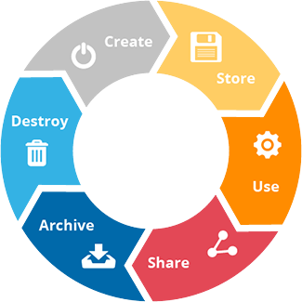

Figure DLM as presented by Spirion

This maps closely to the ODLM which we started with, which can be seen in the following table:

Table ODLM Mapped to Spirion Model

|  |  |
| --- | --- |
| **Original Model** | **Spirion model** |
| Create | Create |
| Control |  |
| Store | Store Archive |
| Index |  |
| Consume | Share |
| Dispose | Destroy |

The final practitioner model examined was the one produced by ITTStars. It highlights the useful features examining the need for data clean-up within the control phase which the ODLM does not present. Again, like others it also draws attention to data description and analysis. They, ITTStars, present it using the following figure:

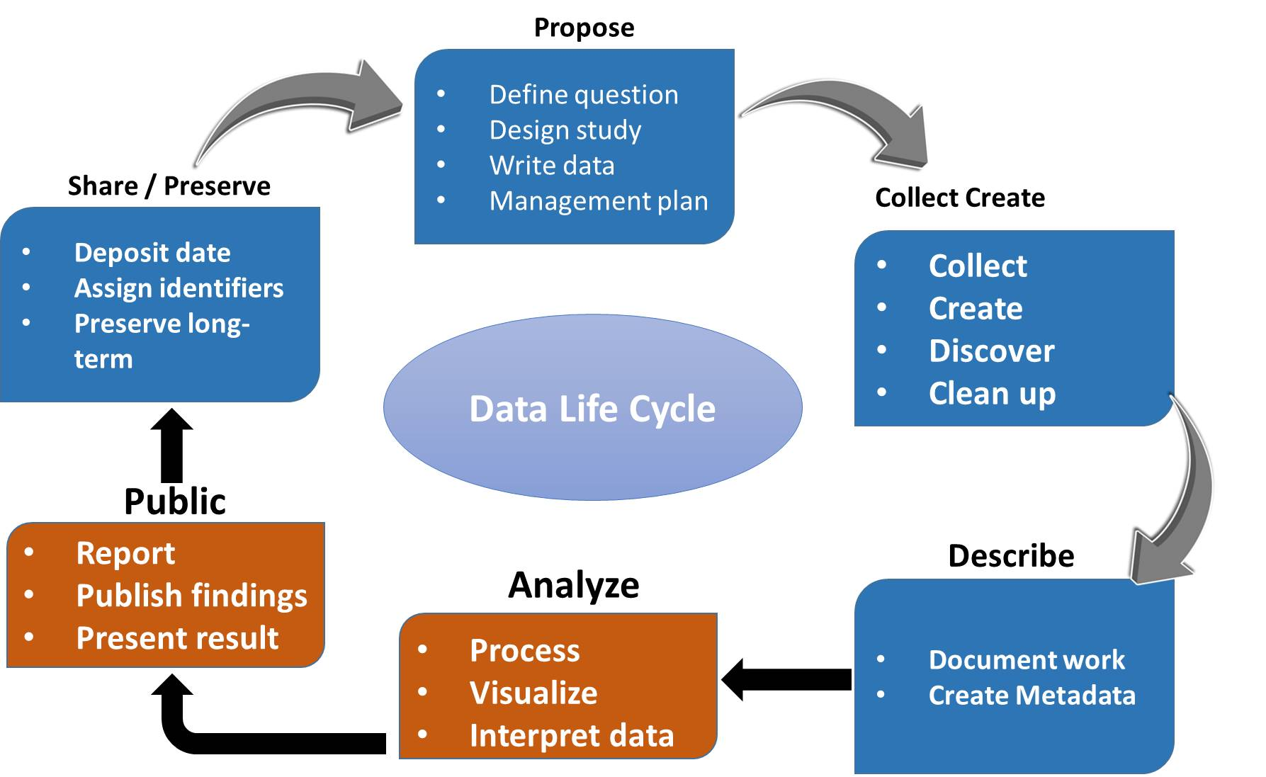

Figure ITTStar DLM

For comparison with the ODLM we can see a high degree of overlap, indicated by the table below:

Table ODLM Mapped to ITTStar Model

|  |  |
| --- | --- |
| **Original Model** | **ITTStar model** |
|  | Purpose |
| Create | Collect Create Describe |
| Control |  |
| Store | Analyze Public Share/Preserve |
| Index |  |
| Consume |  |
| Dispose |  |

# Changes to the data lifecycle model arising from the literature

This section describes the changes to the data model resulting from the literature review and acknowledges the source of those modifications. The following section “Modified model” describes the modified data model and contains the definition of each stage and corresponding activities in that phase.

By looking at the mapping of the ODLM and the model presented it is clear that at a high lever there are no gaps in the ODLM, with th possible exception of Purpose from ITTStar model. Purpose is essentially the intended use of the data and predates it’s creation and so is it truly part of its lifecycle, that said for a dataset identification of its purpose can indicate it's intended use and value. For this reason, I propose to add it to the lifecycle.

There are two other concepts of data that are given prominence in the preceding models. These are reuse or repurposing and publication.

The act of reusing data, even if for a different purpose opens up all sorts of questions about the value of the use, is the data being used and interpreted correctly. This is a fact of data consumption. As such, it will be added as part of consumption.

Publication is more problematic. Once data is published it is no longer controlled and may even be duplicated. Once published we can not assume that the data is ever going to be deleted. Therefore, the mode will assume that published data is a new data lifecycle in its own right. This implies that the publication of the data is outside of the controlled lifecycle. This is intentional, publication within the lifecycle is simply another form of consumption.

## Changes to the horizontal component of the model

The ODLM has a horizontal bar that represents the activities that exist throught the lifecycle of the data. This was originally defined as being composed of three components:

With the addition of these two steps the high-level data lifecycle model is represented as:

* Purpose
* Create
* Control
* Store
* Index
* Consume
* Publish
* Dispose

Needless to say while some of these steps happen in sequence, such as Propose must come before Create, others can happen in parallel, such as Store and Index and other in reverse order, such as consumption may lead to the date being modified and restored.

## Definition of the model

This section presents the latest version of the DLM with in more detail, highlighting the typical activities that occur in each stage and providing a definition of the activity. Each stage has one or more activities associated with it. Each stage will be presented as the stage the activities and a definition of the activity. Where the definitions are tasked directly from another source, that source will be referenced

Table Data Lifecycle Model

|  |  |
| --- | --- |
| **Purpose** | |
| *Setting purpose* | Defining and stating the purpose for the data object to be collected or created. This may be extended to include data definition and format data. |
| *Preservation planning* | *Strategies, policies and procedures for all curation actions* (Ball, 2012, pg. 3)  This should include the approach and policies relating to data retention and disposition (deletion). |
| **Create** | |
| *Creation* | Creation of a new data object either by human content creation, human entry of data or by automatic means. |
| *Modification* | Modification of existing data object resulting in a new data record being created. |
| *Duplication* | Duplicating of an existing data record. |
| **Control** | |
| *Capture* | Capturing the data object and associate meta data |
| *Direction* | Ensuring that data is sent to the correct repository or repositories and that it is indexed accordingly. |
| *Encryption* | Encrypting the data object |
| *Validation* | Ensuring the data object is complete and fit for purpose within either defined standards or acceptable norms. The goal is to ensure the data quality. |
| *Enriching* | Addition of meta data about the data object or its contents this might include:   * Stamping meta data such as date, location or time * Extracting meta data such a converting voice to text * Additional date to describe the data object * Additional date to describe content within the data object * Analysis and creation of meta data to support later analytical or exploratory purposes. |
| *Describing* | A computer-generated description of the data object |
| *Transformation* | Performing operations to transform the data object and or its meta data. |
| **Store** | |
| *Storing* | Locating the data object into an operational storage location or locations |
| *Archiving* | Locating the data object into an archival storage location or locations |
| **Index** | |
| *Indexing* | Indexing the data object. This makes it possible to search for the object and for it to be processed. The data object is this accessible via the index.  The index may or may not store the object’s meta data and enrichments. |
| **Consumption** | |
| *Read* | Accessing either the data object and/or the data object’s meta data. |
| *Process* | Performing some type of process using the data orject and or it’s meta data. This may result in the creation of a new data object. |
| *Analytics* | Preforming an analytical operation or set of operations using the data object and or it’s meta data. This may result in the creation of a new data object. |
| *Modification* | Modification the data object, its index or meta data. This may mean the creation of a new data object. |
| *Export* | Creating a deat record outside of the control od the data lifecycle containing data objects and or their meta data or subsets there of. |
| *Reuse* | Using for data object and/or it’s meta data for a purpose for which it wasn’t intended. |
| **Publishing** | |
| *Publishing* | Making data objects and/or their meta data available to the public domain. This is assumed to enable data duplication and the data objects should be assumed to persist indefinitely. |
| **Disposition** | |
| *Data destruction* | Deletion of all instances of the data object and possible it’s meta data. To be controlled it should be performed as part of a retention & disposition policy framework.  Disposition may also describe or require the nature of data destruction which can include removal of the index, over writing the data or destruction of the storage medium. |

The following table describes the items that compose the cross life-cycle stages. These are what we understand to be necessary best practice activities.

Table Cross data lifecycle activities

|  |  |
| --- | --- |
| **Cross data lifecycle activities** | |
| *Retention* | Policies and mechanisms in place to ensure that data objects and meta data or not destroyed or removed whiles they are still required |
| *Hold* | A specific mechanism to ensure data is retained, in addition to the retention policies. |
| *Disposition* | A mechanism and policies to ensure data is removed or destroyed at the appropriate time. Best practice is that disposition policies take lower precedence than hold or retention. As such data that is under hold or retained can not be disposed of. |
| *Temporal immutability* |  |
| *Data object lifecycle tracking and reporting* |  |
| *Data object activity tracking and reporting* |  |
| *Security* |  |
| *Data object content verification* |  |

Combined this presents a data lifecycle model that can be visualized as follows:



Figure Data Lifecycle Model (DLM)

# Conclusion

It is the opinion of the author that this the review of this topic has been only curcory and further research would be valuable. That said the sample of literature surveyed suggests that the body of research to date has been focused on research practices and not practice in the public or private sector. Further work in these sectors would be valuable.

That said for all the limitations of the shortcomings of the research the model produced is sufficient to conduct the next stage of research which is to define a model for data lifecycle cost modeling and data lifecycle value modeling.

# Bibliography

Balasubramanian, J., Belker, S., Chauhan, S., Colombo, T., Hansson, F., Inampudi, S., … Kässer, M. (2016). Car data: paving the way to value-creating mobility. *McKinsey & Company*, (March). Retrieved from https://www.mckinsey.com/~/media/McKinsey/Industries/Automotive and Assembly/Our Insights/Creating value from car data/Creating value from car data.ashx

Ball, A. (2012). Review of Data Management Lifecycle Models., 15. Retrieved from https://purehost.bath.ac.uk/ws/portalfiles/portal/206543/redm1rep120110ab10.pdf

Bloomberg Professional Services. (2015). 7 phases of a data life cycle | Bloomberg Professional Services. Retrieved July 16, 2018, from https://www.bloomberg.com/professional/blog/7-phases-of-a-data-life-cycle/

Data Documentation Initiative. (n.d.). Retrieved October 6, 2018, from http://www.ddialliance.org/

FINRA. (2014). *Records to be preserved by certain exchange members, brokers and dealers SEA Rule 17a-4*. Retrieved from https://www.finra.org/sites/default/files/SEA.Rule_.17a-4.Interpretations_0_0.pdf

Higgins, S. (2008). The DCC Curation Lifecycle Model. *International Journal of Digital Curation*, *3*(1), 134–140. https://doi.org/10.2218/ijdc.v3i1.48

ITT Star. (2018). IT Datamanagement | ITTStar Consulting LLC. Retrieved October 6, 2018, from http://www.ittstar.com/it_data.html

Khoso, M. (2016). How Much Data is Produced Every Day? Retrieved August 20, 2017, from http://www.northeastern.edu/levelblog/2016/05/13/how-much-data-produced-every-day/

Lenhardt, W., Ahalt, S., Blanton, B., Christopherson, L., & Idaszak, R. (2014). Data Management Lifecycle and Software Lifecycle Management in the Context of Conducting Science. *Journal of Open Research Software*, *2*(1), e15. https://doi.org/10.5334/jors.ax

Miller, K., Miller, M., Moran, M., & Dai, B. (2018). Data Management Life Cycle, Final report. Retrieved from https://static.tti.tamu.edu/tti.tamu.edu/documents/PRC-17-84-F.pdf

Modeling the global economic impact of AI | McKinsey. (n.d.). Retrieved September 24, 2018, from https://www.mckinsey.com/featured-insights/artificial-intelligence/notes-from-the-ai-frontier-modeling-the-impact-of-ai-on-the-world-economy

Moore, G. E. (2007). David C. Brock(Editor). Understanding Moore’s Law: Four Decades of Innovation . x + 160 pp., illus., notes, index. Philadelphia: Chemical Heritage Foundation, 2006. $12 (paper). *Isis*, *98*(4), 887–887. https://doi.org/10.1086/529346

Nind, T., Galloway, J., McAllister, G., Scobbie, D., Bonney, W., Hall, C., … Jefferson, E. (2018, July 1). The research data management platform (RDMP): A novel, process driven, open-source tool for the management of longitudinal cohorts of clinical data. *GigaScience*. Oxford University Press. https://doi.org/10.1093/gigascience/giy060

Radicati, S., & Hoang, Q. (2017). *Email Statistics Report, 2017-2021*. *Email Statistics report, 2017-2021 - Executive Summary* (Vol. 44). London. Retrieved from http://www.radicati.com

Regulatory Notice 17-18 Guidance on Social Networking Websites and Business Communications. (2017). *FINRA Regulatory Noticees*.

Sohn, A. (2017). You Want to do What With Your Data? Retrieved September 8, 2018, from https://bigdata.cioreview.com/cxoinsight/you-want-to-do-what-with-your-data-nid-27091-cid-15.html

Spirion. (n.d.). Data Lifecycle Management (DLM) | Spirion. Retrieved October 6, 2018, from https://www.spirion.com/data-lifecycle-management/

UK Data Service. (n.d.). UK Data Service » Research data lifestyle. Retrieved October 6, 2018, from https://www.ukdataservice.ac.uk/manage-data/lifecycle

V Cloud News. (2015). Every day Big Data Statistics - 2.5 Quintillion Bytes of Data Created Daily. Retrieved August 20, 2017, from http://www.vcloudnews.com/every-day-big-data-statistics-2-5-quintillion-bytes-of-data-created-daily/

Wang, Y., Kung, L. A., & Byrd, T. A. (2018). Big data analytics: Understanding its capabilities and potential benefits for healthcare organizations. *Technological Forecasting and Social Change*, *126*, 3–13. https://doi.org/10.1016/j.techfore.2015.12.019

1. The **zettabyte** is a multiple of the unit [byte](https://en.wikipedia.org/wiki/Byte) for [digital information](https://en.wikipedia.org/wiki/Computer_data_storage). The [prefix](https://en.wikipedia.org/wiki/SI_prefix) [zetta](https://en.wikipedia.org/wiki/Zetta-) indicates multiplication by the seventh power of 1000 or 1021 in the [International System of Units](https://en.wikipedia.org/wiki/International_System_of_Units) (SI). A zettabyte is one sextillion bytes. The unit symbol is **ZB**. 1 ZB = 10007bytes = 1021bytes = 1000000000000000000000bytes.

   A related unit, the [zebibyte](https://en.wikipedia.org/wiki/Zebibyte) (ZiB), using a [binary prefix](https://en.wikipedia.org/wiki/Binary_prefix), is equal to 10247 (=270) bytes (approximately 1.181 ZB).(Source: <https://en.wikipedia.org/wiki/Zettabyte>)
2. Secure may imply encryption. In the original model this is part of the previous step